Unit Testing

* Black Box

|  |  |  |  |
| --- | --- | --- | --- |
| Input | Proses | Output | Hasil Uji |
| Tambah supplier | Post data & create data (database) | Tambah data berhasil | Berhasil |
| Edit supplier | Get/Post data (by id) & update data (database) | Edit data berhasil | Berhasil |
| Hapus supplier | Get data (by id) & hapus data (database) | Hapus data berhasil | Berhasil |
| Tambah material | Post data & create data (database) | Tambah data berhasil | Berhasil |
| Edit material | Get/Post data (by id) & update data (database) | Edit data berhasil | Berhasil |
| Hapus material | Get data (by id) & hapus data (database) | Hapus data berhasil | Berhasil |

* White Box (with automate test odoo)

Script Test Module

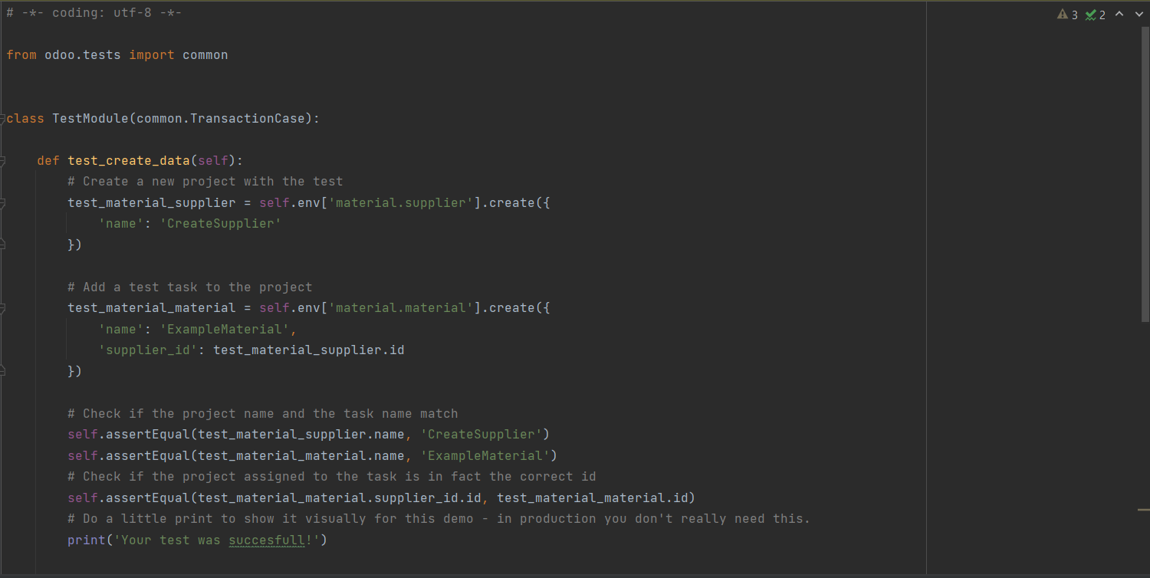

Result Test Module

